# CHAPTER 1

# INTRODUCTION

The Project named “Pharmacy Management System”, a Medical information system is a client/server based application.

AnInteractiveapplicationformanagingbothStockandBillingwhichhelpsin maintainingtherecordsofthemedicine,theusersandstoredetailsandalsoreducethe work of searching the medicine. The main aim of this application is to apply technologyissupportingthepharmacist andthestoretoreducethehuman efforton searching and automation of thebilling.

The project has been developed on the basis of “Stock managing” and it’s “billingprocess”beingpresentlyusedinthemedicalstoresforstoringandretrieving the available information in thestore.

Theuserhastogethisusernameandpasswordfromtheadminbyprovidingthe name,address,phoneno,idproof.Andcangettheaccesstotheapplication.Without the username and password he cannot get access to theapplication.

Inthisapplicationwehavefourtypesofuserswhohavetheirspecifiedworkto performandwhileloggingintotheapplicationheshouldbeknowinghisdesignation tologin.andinthiswecanmanageallthestocksofthestoreandcanmanageit.

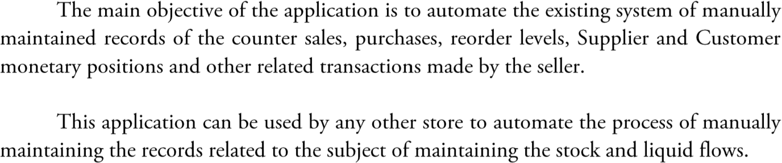



**LITERATURE SURVEY**



**2.1 History of Pharmacy ManagementSystem**

The**pharmacymanagementsystem**,alsoknownasthe**pharmacyinformationsystem**,isa system that stores data and enables functionality that organizes and maintains the medication use process withinpharmacies.

Thesesystemsmaybeanindependenttechnologyforthepharmacy'suseonly,orinahospital setting, pharmacies may be integrated within an inpatient hospital [computer physician orderentry (CPOE)](https://en.wikipedia.org/wiki/Computerized_physician_order_entry)system.

Necessary actions for a basic, functioning pharmacy management system include a user interface, data entry and retention, and security limits to protect patient health information. Pharmacy computer software is usually purchased ready made or provided by a drug wholesaler as part of theirservice.

Variouspharmacysoftwareoperatingsystemsareusedthroughoutthemanypracticesettings of pharmacy across theworld.



**2.2 History of MySQL**

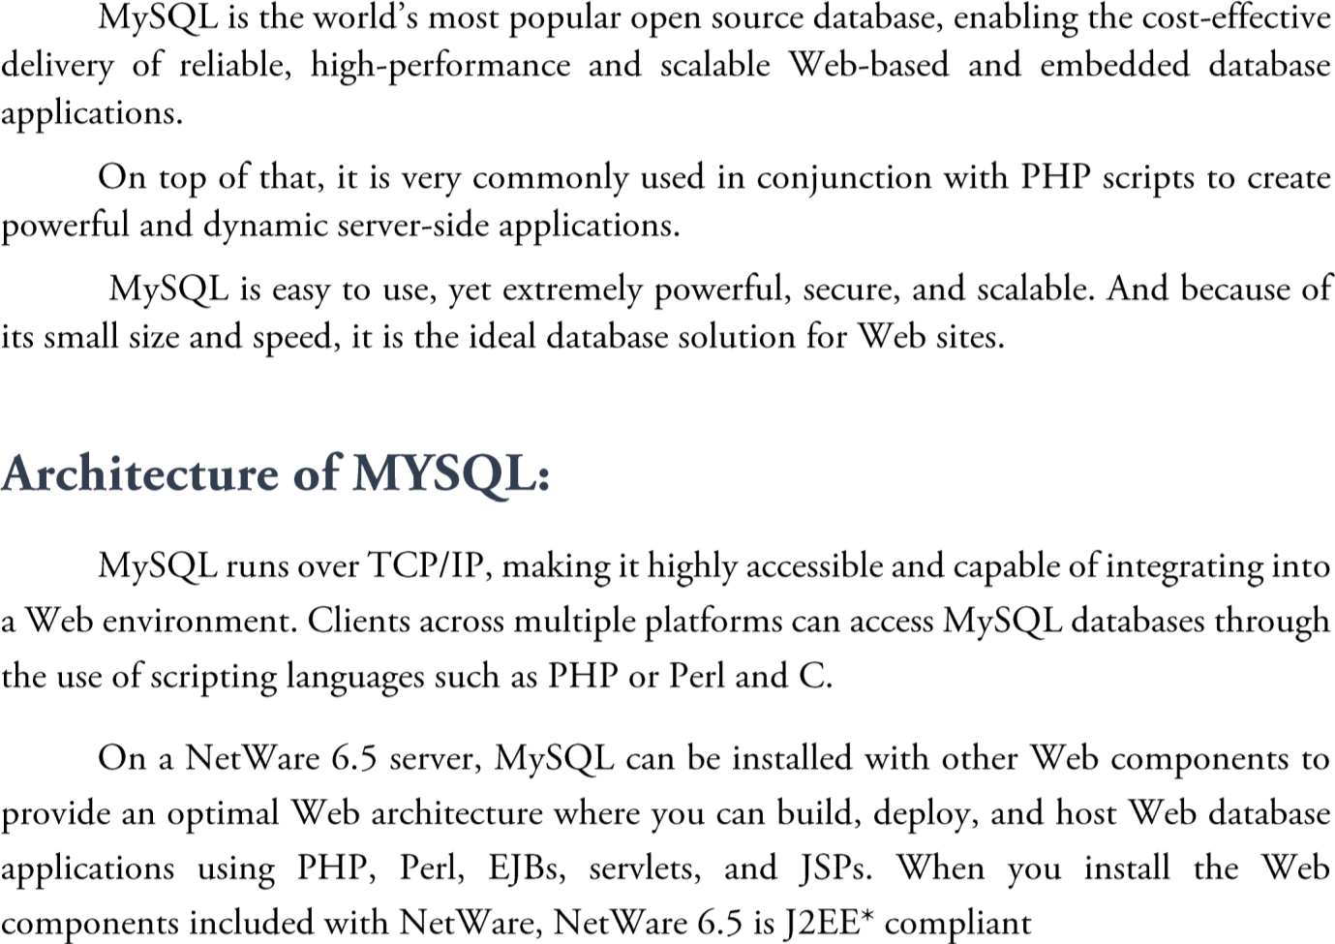

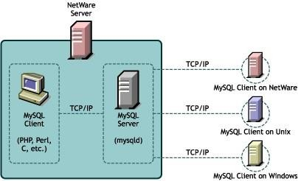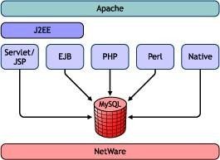



**REQIREMENT SPECIFICATION**

## System Requirements

The basic requirements for the development of this mini project are as follows

## Hardware Configuration

1. Processor: Intel core i3 orabove
2. Ram:512 MB
3. Hard disk:20GB

## SoftwareConfiguration

1. Front end tool:HTML
2. Back end tool:PHP
3. Development tools: XAMPPserver
4. Browser: Google orany
5. Documentation tool: Microsoft office 2003 orabove

## Development Environment Frontend-HTML

Itis the standa[rd mark-up language](https://en.wikipedia.org/wiki/Markup_language) for creating [web pages](https://en.wikipedia.org/wiki/Web_page) and web applications. With [CascadingStyleSheets](https://en.wikipedia.org/wiki/Cascading_Style_Sheets)(CSS)and [JavaScript](https://en.wikipedia.org/wiki/JavaScript),itformsatriadof[cornerstone](https://en.wikipedia.org/wiki/Cornerstone)technologiesforthe[WorldWideWeb.](https://en.wikipedia.org/wiki/World_Wide_Web)[Webbrowsers](https://en.wikipedia.org/wiki/Web_browser) receive HTML documents from a [web server](https://en.wikipedia.org/wiki/Web_server) or from local storage and render the documents into multimediawebpages.HTMLdescribesthestructureofawebpage[semantically](https://en.wikipedia.org/wiki/Semantic_Web)andoriginallyincludedcues for the appearance of the document.HTML can embed programs written in a [scripting language](https://en.wikipedia.org/wiki/Scripting_language) such as [JavaScript,](https://en.wikipedia.org/wiki/JavaScript) which affects the behaviour and content of web pages. Inclusion of CSS defines the look and layout of content. The [World Wide Web Consortium](https://en.wikipedia.org/wiki/World_Wide_Web_Consortium) (W3C), maintainer of both the HTML and the CSS standards, has encouraged the use of CSS over explicit presentational HTML since1997.

## Frontend-HTML

Itis the standa[rd mark-up language](https://en.wikipedia.org/wiki/Markup_language) for creating [web pages](https://en.wikipedia.org/wiki/Web_page) and web applications. With [CascadingStyleSheets](https://en.wikipedia.org/wiki/Cascading_Style_Sheets)(CSS)and [JavaScript](https://en.wikipedia.org/wiki/JavaScript),itformsatriadof[cornerstone](https://en.wikipedia.org/wiki/Cornerstone)technologiesforthe[WorldWideWeb.](https://en.wikipedia.org/wiki/World_Wide_Web)[Webbrowsers](https://en.wikipedia.org/wiki/Web_browser)receiveHTMLdocumentsfroma[webserver](https://en.wikipedia.org/wiki/Web_server)orfromlocalstorageand renderthedocumentsinto

multimediawebpages.HTMLdescribesthestructureofawebpage[semantically](https://en.wikipedia.org/wiki/Semantic_Web)andoriginallyincludedcues for the appearance of the document.HTML can embed programs written in a [scripting language](https://en.wikipedia.org/wiki/Scripting_language) such as [JavaScript,](https://en.wikipedia.org/wiki/JavaScript) which affects the behaviour and content of web pages. Inclusion of CSS defines the look and layout of content. The [World Wide Web Consortium](https://en.wikipedia.org/wiki/World_Wide_Web_Consortium) (W3C), maintainer of both the HTML and the CSS standards, has encouraged the use of CSS over explicit presentational HTML since1997.

## Backend-MySQL

Itis an open source relational database management system (RDBMS).

TheMySQLdevelopmentprojecthasmadeitssourcecodeavailableunderthetermsofGNUGeneralPublic License, as well as under a variety of proprietary agreements. MySQL was owned and sponsored by a single for-profit firm, the Swedish company MySQL AB, now owned by Oracle Corporation. For proprietary use, several paid editions are available, and offered additional functionality. MySQL is central component of LAMP open-source web application software stack. LAMP is an acronym of “Linux, Apache, MySQL, Perl/PHP/Python”. Application that use the MySQL database include TTPO3, MODx, Joomal, WordPress, phpBB, MyBB, and Drupal. MySQL is also used in many high-profile. Large-scale websites, including Google, Facebook, Twitter, Flickr,YouTube.

**PHP**

PHP is a server-side scripting language designed for web development but also used as a general-purpose programminglanguage.PHPisnowinstalledonmorethan244millionwebsitesand2.1millionwebservers. Originally created by RasmusLerdorf in 1995, the reference implementationof PHP is now produced by The PHP Group. While PHP originally stood for Personal Home Page, it now stands for PHP: Hypertext Preprocessor,arecursivebackronym.PHPcodeisinterpretedbyawebserverwithaPHPprocessormodule, which generates the resulting web page: PHP commands can be embedded directly into an HTML source document rather than calling an external file to process data. It has also evolved to include a command-line interfacecapabilityandcanbeusedinstandalonegraphicalapplications.PHPisfreesoftwarereleasedunder the PHP License. PHP can be deployed on most web servers and also as a standalone shell on almost every operating system and platform, free ofcharge.

**APACHE**

The Apache HTTP Server is a web server software notable for playing a key role in the

initial growth of the World Wide Web. In 2009 it became the first web server software to surpass the 100 millionwebsitemilestone.Apacheisdevelopedandmaintainedbyanopencommunityofdevelopersunder the auspices of the Apache Software Foundation. Since April 1996 Apache has been the most popular HTTP serversoftwareinuse.AsofNovember2010Apacheservedover59.36%ofallwebsitesandover66.56%of the first one million busiestwebsites.

**XAMPP**

XAMPPisasmallandlightApachedistributioncontainingthemostcommonwebdevelopmenttechnologies in a single package. Its contents, small size, and portability make it the ideal tool for students developing andtestingapplicationsinPHPandMySQL.XAMPPisavailableasafreedownloadintwospecificpackages: full and lite. While the full package download provides a wide array of development tools ,XAMPP Lite contains the necessary technologies that meet the Ontario Skills Competition standards. The light version is a small package containing Apache HTTP Server, PHP, MySQL, phpMyAdmin, Openssl, andSQLite.

|  |  |
| --- | --- |
| **Development status** | Active |
| **Written in** | [C,](https://en.wikipedia.org/wiki/C_(programming_language)) [C++](https://en.wikipedia.org/wiki/C%2B%2B)[[3]](https://en.wikipedia.org/wiki/MySQL#cite_note-3) |
| [**Operating system**](https://en.wikipedia.org/wiki/Operating_system) | [Windows](https://en.wikipedia.org/wiki/Microsoft_Windows), [Linux](https://en.wikipedia.org/wiki/Linux), [Solaris](https://en.wikipedia.org/wiki/Solaris_(operating_system)), [macOS](https://en.wikipedia.org/wiki/MacOS), [FreeBSD](https://en.wikipedia.org/wiki/FreeBSD)[[4]](https://en.wikipedia.org/wiki/MySQL#cite_note-4) |
| **Available in** | [English](https://en.wikipedia.org/wiki/English_language) |
| [**Type**](https://en.wikipedia.org/wiki/Software_categories#Broad_categories) | [RDBMS](https://en.wikipedia.org/wiki/Relational_database_management_system) |
| [**License**](https://en.wikipedia.org/wiki/Software_license) | [GPL](https://en.wikipedia.org/wiki/GNU_General_Public_License)(version 2) or [proprietary](https://en.wikipedia.org/wiki/Proprietary_software)[[5]](https://en.wikipedia.org/wiki/MySQL#cite_note-5) |
| **Website** | [www.mysql.com](http://www.mysql.com/) |

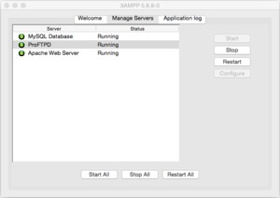

[**Developer(s)**](https://en.wikipedia.org/wiki/Software_developer)

Apache Friends

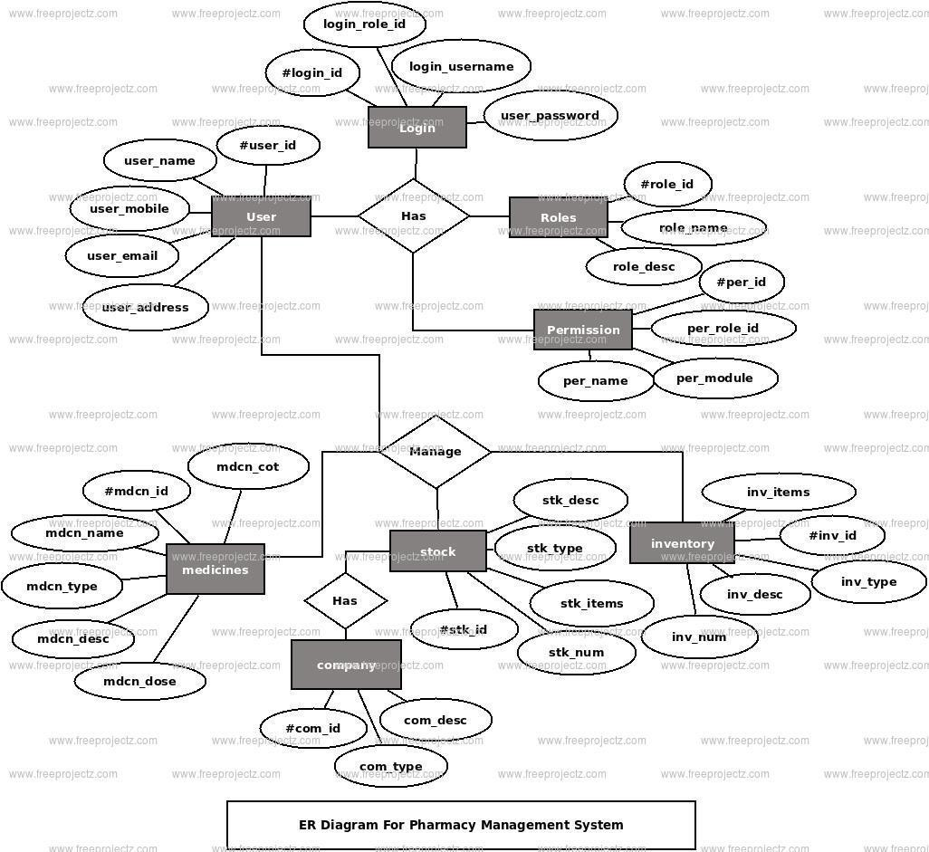



**System Design**



**4.1 E-R Diagram**

Anentity–relationshipmodel(ERmodel)describesinter-relatedthingsofinterestinaspecificdomain of knowledge. An ER model is composed of entity types (which classify the things of interest) and specifies relationships that can exist between instances of those entitytypes.

In software engineering an ER model is commonly formed to represent things that a business needs to remember in order to perform business processes. Consequently, the ER model becomes an abstract data modelthatdefinesadataorinformationstructurethatcanbeimplementedinadatabase,typicallyarelational database.

## SchemaDiagram

The database schema of a database system is its structure described in a formal language supported by the database management system (DBMS). The term "schema" refers to the organization of data as a blueprint of how the database is constructed (divided into database tables in the case of relational databases). The formal definition of a database schema is a set of formulas (sentences) called integrity constraints imposed on a database.

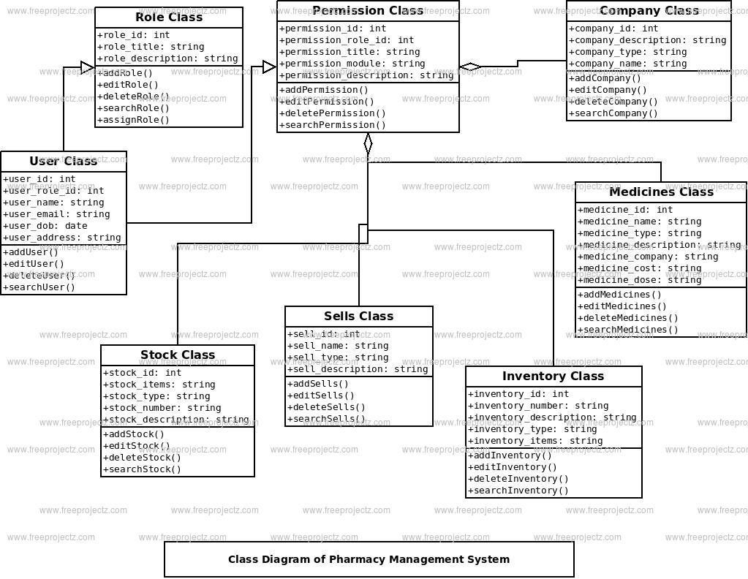

## Pseudo codes for Pharmacy Management System Algorithm for TableDisplay

**Step 2:** Establish connection with the database

**Step 3:** Define ArrayList to return all the values from the method passed. **Step 4:** Define the select query to retrieve all the values from the DBMS **Step 5:** Pass all the values into the ArrayList method.

**Step6:**DefineDefaultTableModelforthetableandusetheArrayListcreatedtodisplayallthevalues stored in it in thetable.

**Algorithm for Insert**

**Step 1: BEGIN**

**Step 2:** Get all the necessary values required for insertion into variable defined in the method.

**Step 3:** Define the query for insertion as stated.

**Step 4:** Execute the Query using the insert method defined.

### Step 5:END

**Algorithm for update**

**Step 1: BEGIN**

**Step 2:** Get all the necessary values required for updating the values into the variable defined in the method.

**Step 3:** Define the Query for Updating as stated above. **Step 4:** Execute the Query using the update method defined. **Step5:END**

## Algorithm for Delete

**Step 2:** Get the identification number of the entity which is to be deleted into a variable defined in the method.

**Step 3:**Display the details and ask whether to confirm the deletion process.

**Step 3:**If yes, define the Query for deleting as stated above.

**Step 4:** Execute the Query using the delete method defined by passing the identification number as an argument.

**Setp5 :** END



CHAPTER 5



**SYSTEM IMPLEMENTATION**

* 1. **ModulesDescription**

**\*Create,** create table statement is used to create table to store data. Integrity constraints like primary key, foreign key, unique key, can be defined while creating the table.

## Create code for every table

* + 1. **AdminTable**

create table admin(

admin_id_name varchar(30) primary key, admin_fname varchar(30),

agent_lname varchar(30), admin_email varchar(30),

admin_role varchar(30), admin_avathar(6));

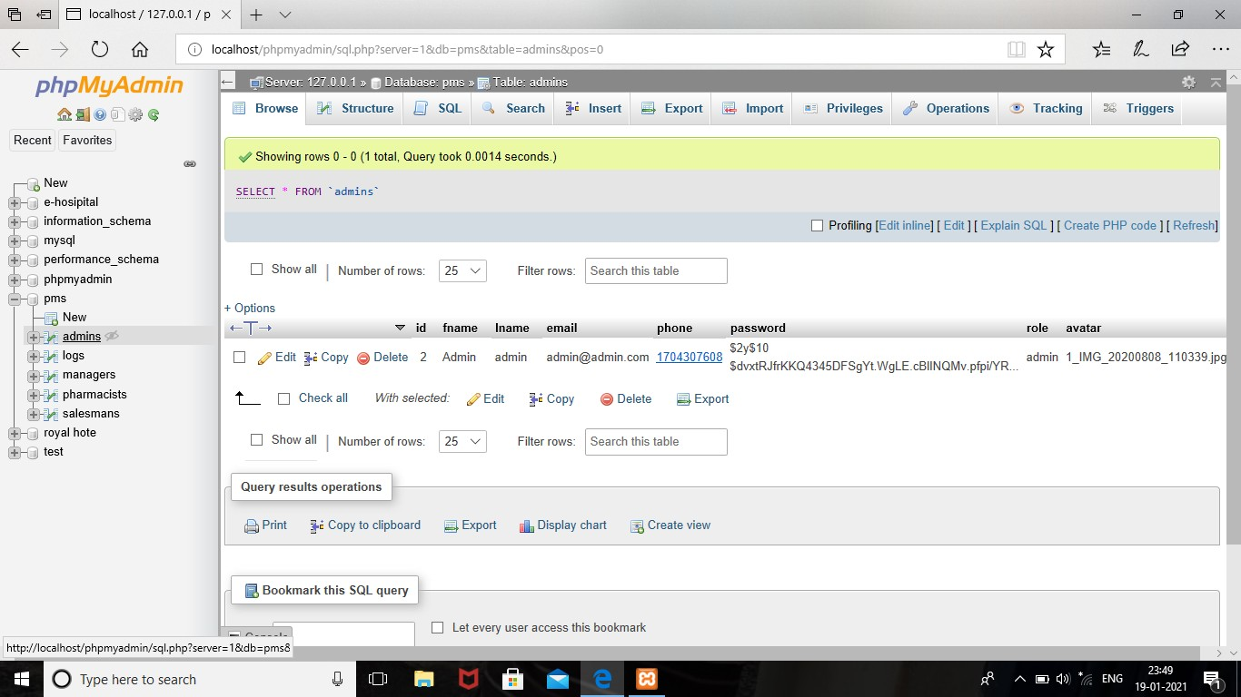

## ManagerTable

Create table manager

(manager_id varchar(30) primary key, manager _fname varchar(20), manager _lname varchar(20), manager _emailvarchar(20),

manager _phone number, manager _role varchar(10), manager_avathar varchar(6)

foreign key(manager_id) references admin_id(admin));

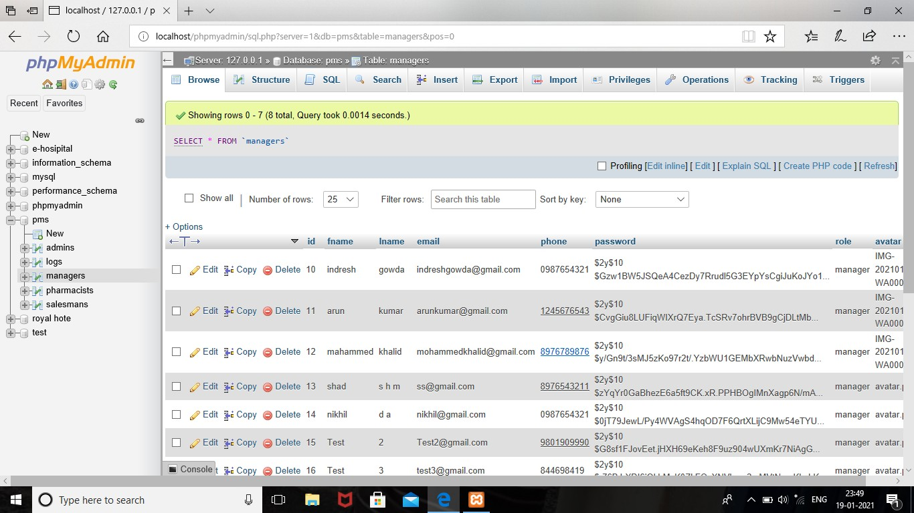

## ParmacistTable

Create table pharmacist

(pid varchar(20) primary key, pfnamevarchar(20),

plname varchar(20), pemail varchar(20), pphone number(10), prole varchar(10), pavatharvarchar(6),

foreign key(pharmacist) references admin_id(admin));

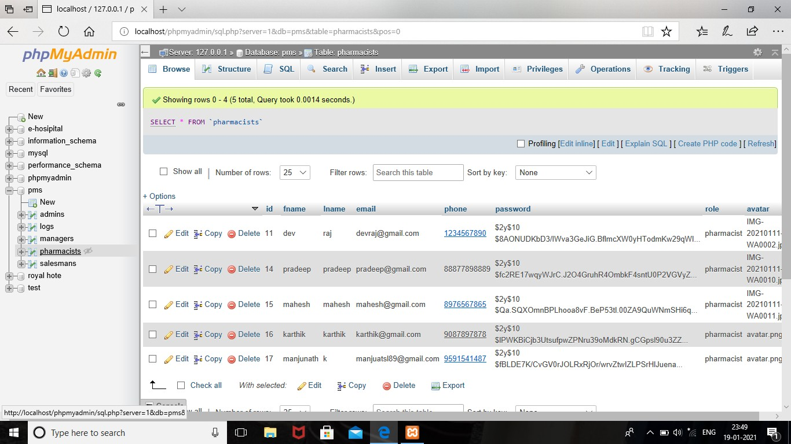

## SalesmanTable

Create table salesman

(sid varchar(10) primary key, sfname varchar(10),

slname varchar(10), semail varchar(20), sphone number(10), srole varchar(10), savathar varchar(6)

foreign key(sid) references admin(admin_id));

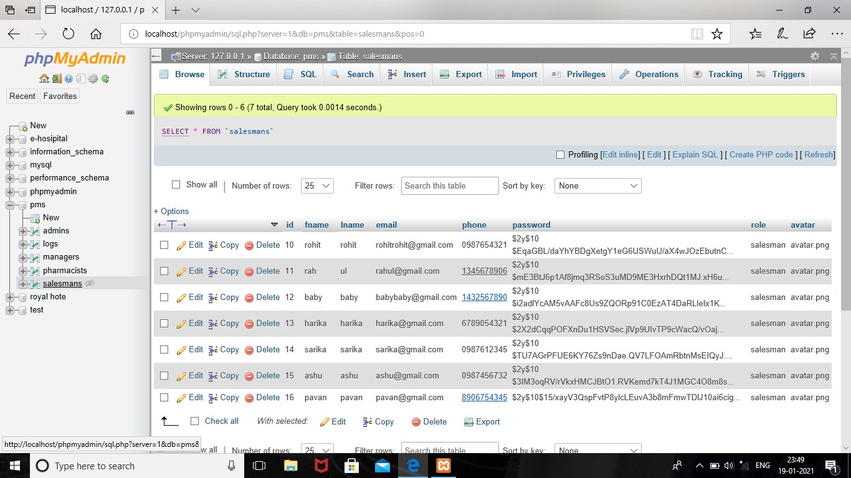

* 1. **OPERATIONSPERFORMED:**

**\*Insertion,** insertion is use to insert the tuple or row to the table. We insert value from frontend by making use HTTP the value inserted from to frontend will be going to store in backend database in XAMPPServer

**\*Update,**updatewillhelptoeditthetablesinthedatabase.Inthisprojectwehavegivenupdateoption for table pharmacist , manager, salesman, to update the place column in respectivetable.

**\*Delete,**deletewillhelpustodeleteatupleorrowfromthetable.Inthisprojectwehavedeleteoption fortablemanagers,pharmacist,salesmantodeletetheparticularroworrespectiveinformationfromthetable.

**\* Trigger,** a trigger is a special kind of stored procedure that automatically executes when an event occurs in the database server. DML triggers execute when a user tries to modify data through a data manipulation language(DML) event. DML events are INSERT, UPDATE, DELETE.

**\*Stored procedure,** a stored procedure is a set of Structure Query Language(SQL) statements with an assigned name, which are stored in a relational database management systemas a group, so it can be reused andsharedbymultipleprograms.Storedprocedurecanaccessormodifydatainadatabase,inthisprojectwe added stored procedure for table package to find income of oursite.

# CHAPTER 6

## 6.1 Screenshots

## 1.LOGINPAGE

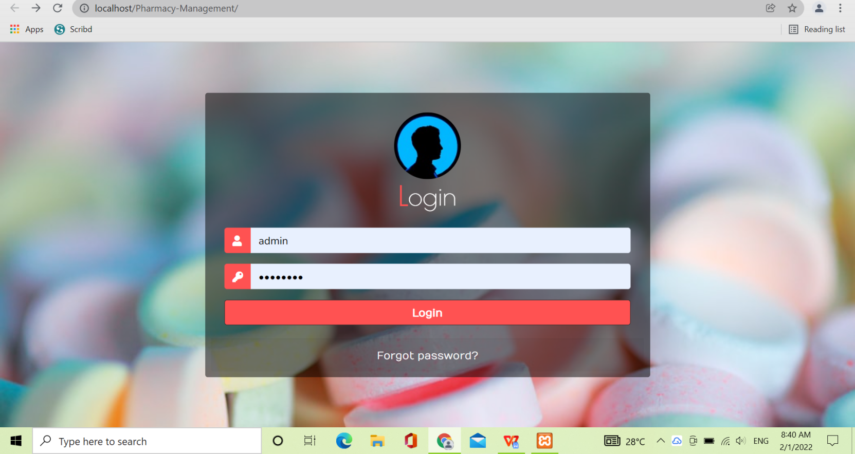

1. **DASHBOARD**

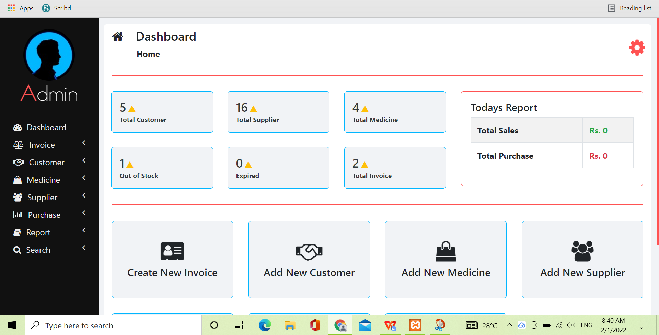

1. **MANAGER DETAILS**

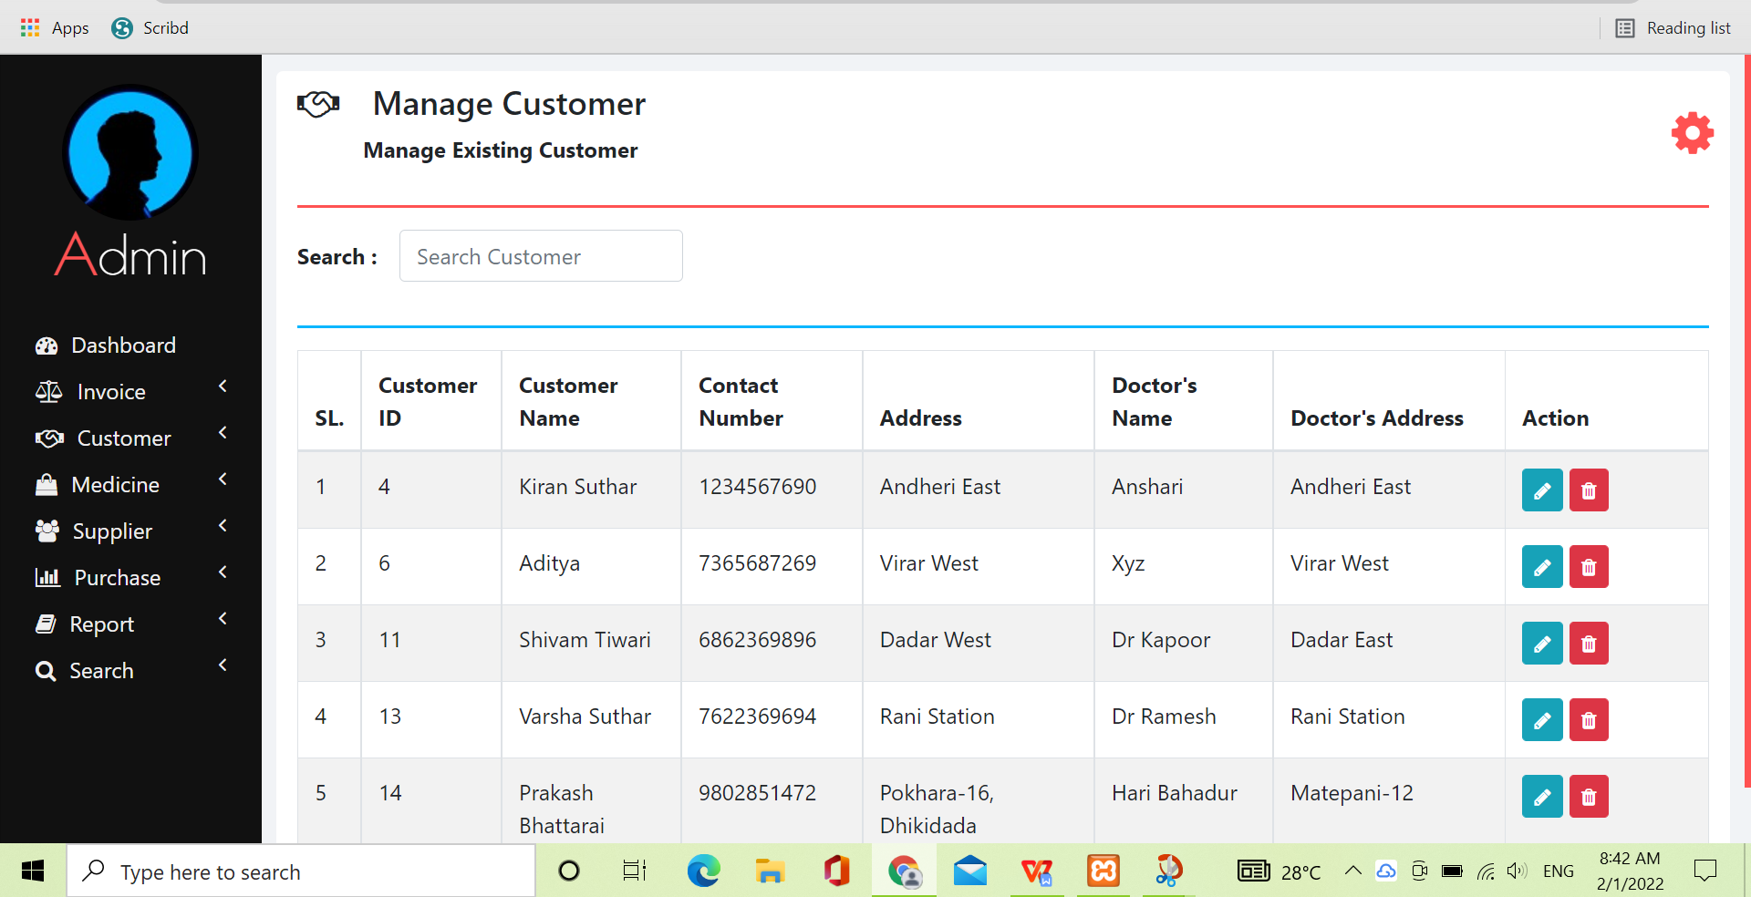

1. **PHARMACISTDETAILS**

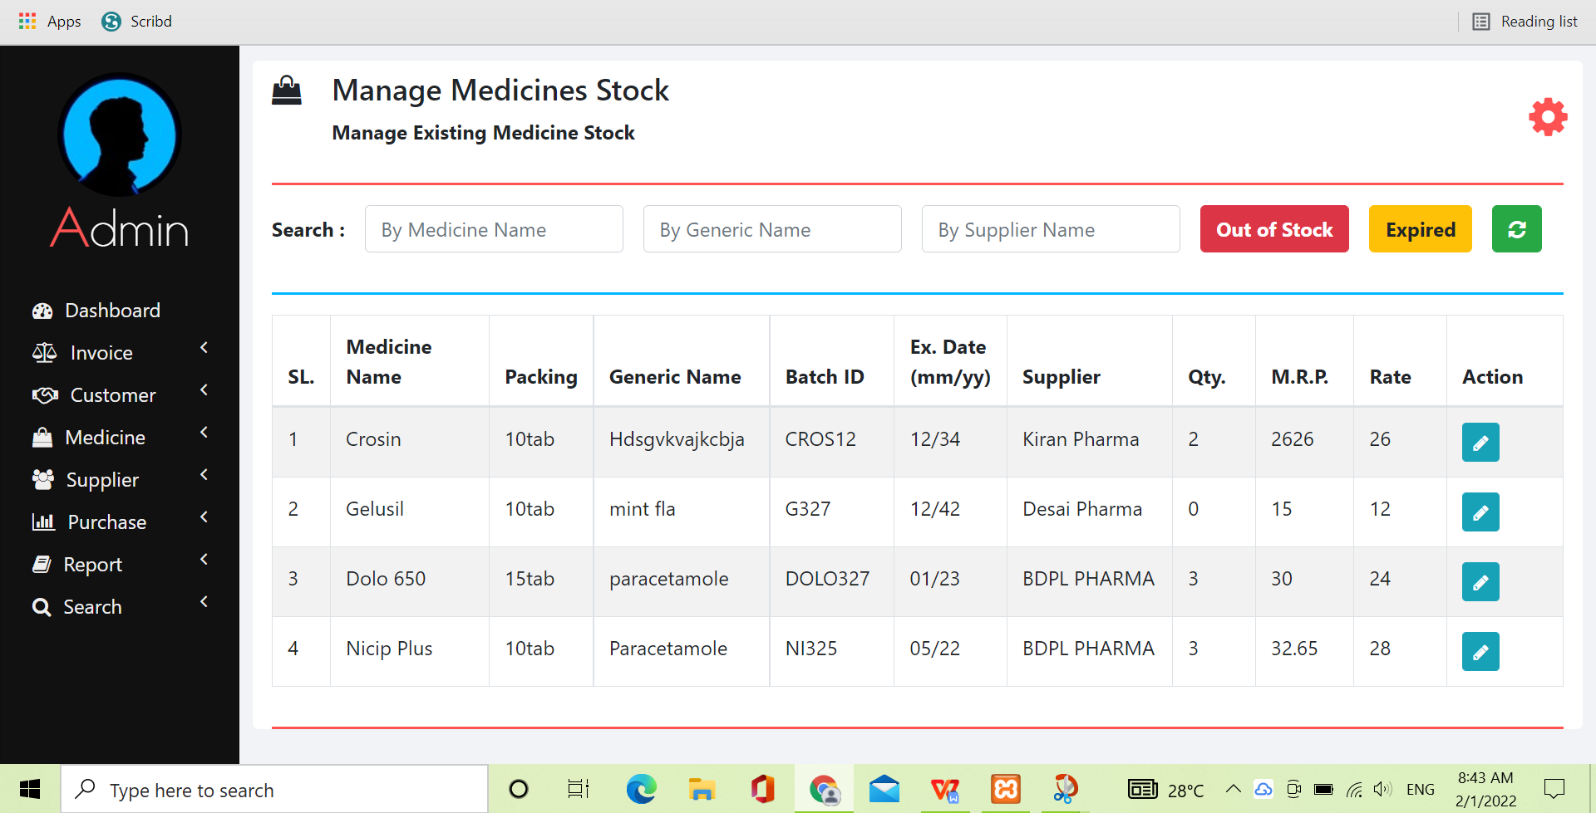

1. **SALESMANDETAILS**

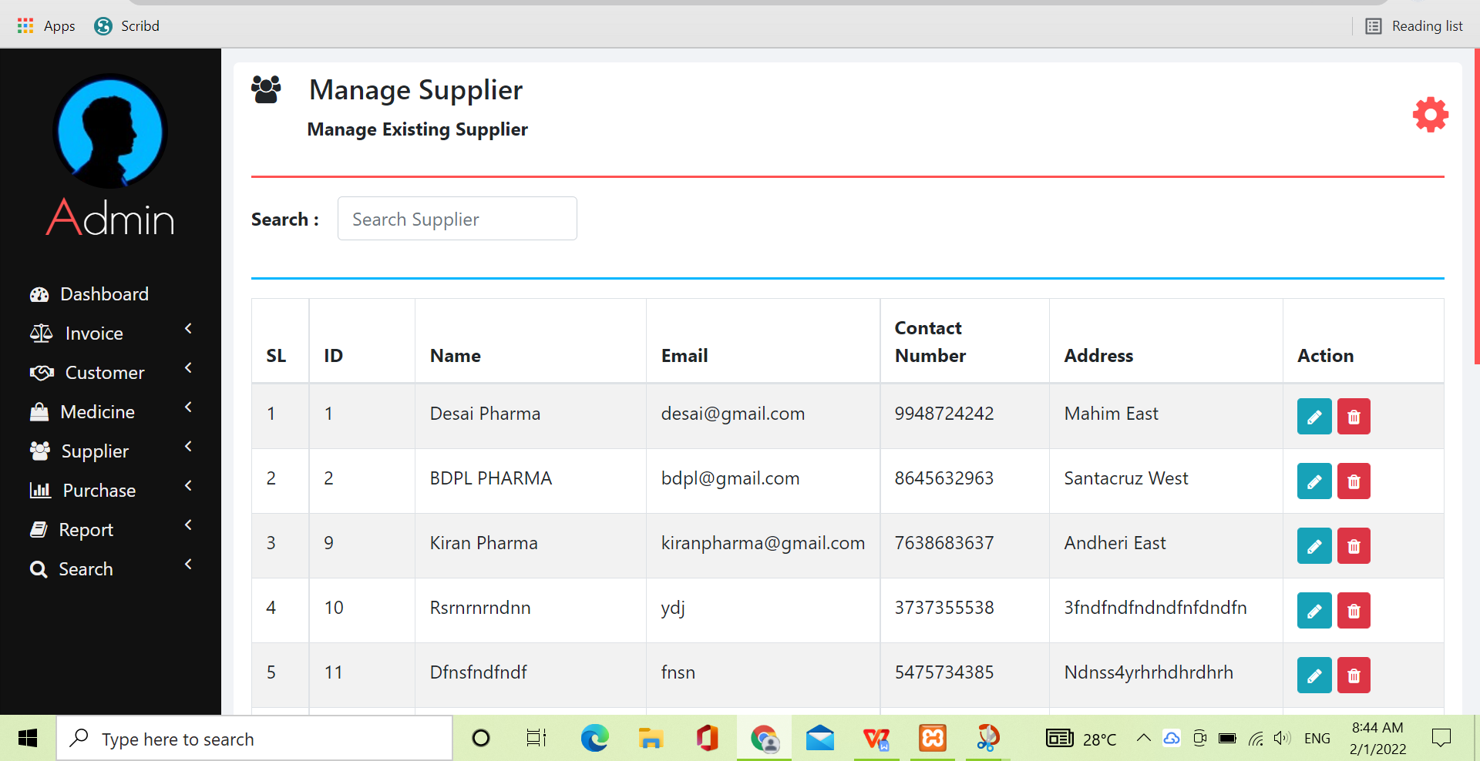1

1. **TRIGGERS**

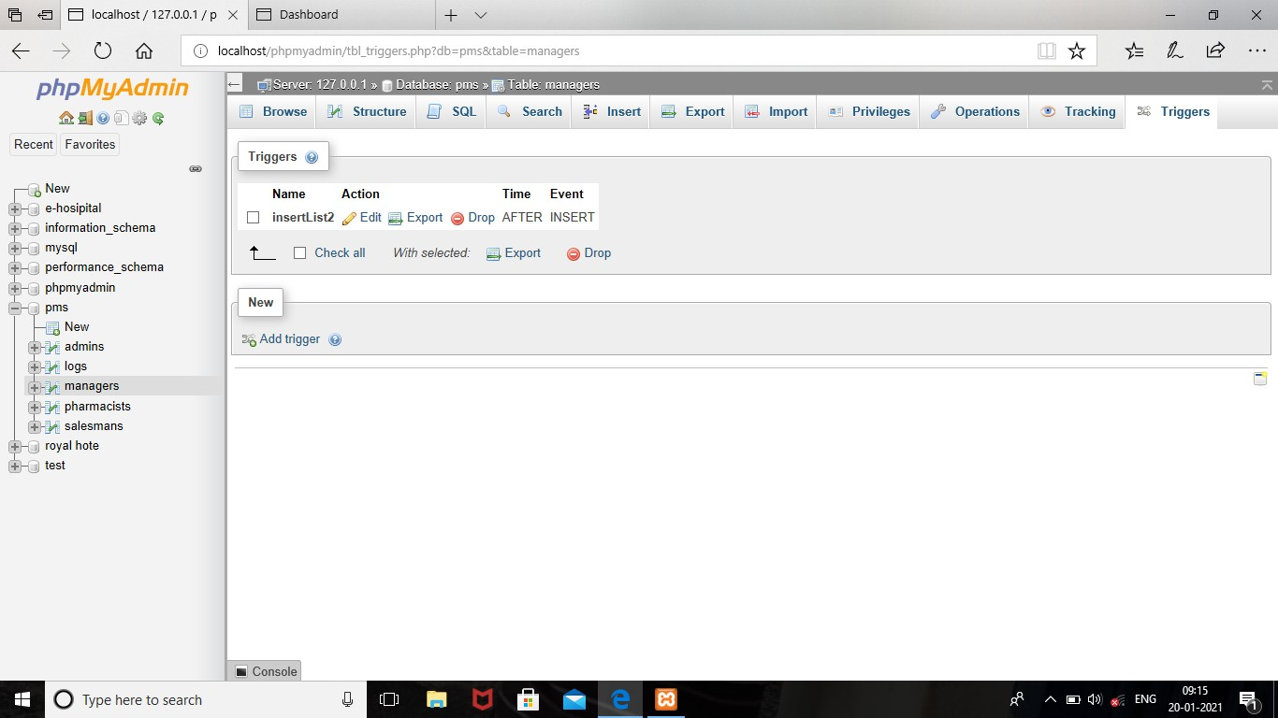

CONCLUSION

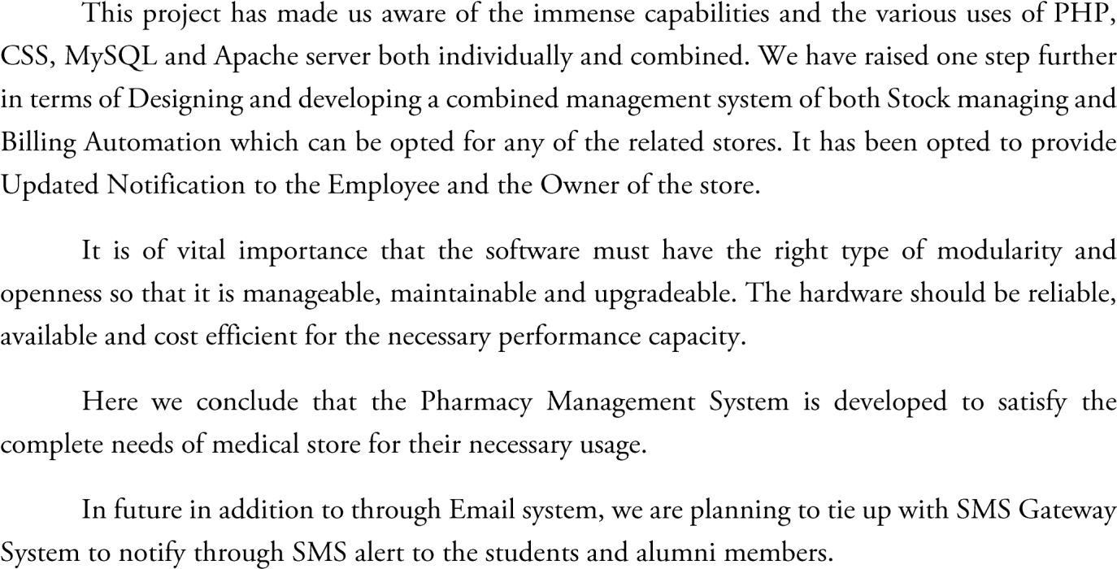

# REFERENCE

* <http://dev.mysql.com/doc/refman/5.0/en/legal-names.html>
* <http://dev.mysql.com/doc/refman/5.0/en/legal-names.html>
* <http://www.w3.org/TR/xhtml1/DTD/xhtml1-transitional.dtd>
* <http://www.w3.org/1999/xhtml>
* <http://www.w3.org/TR/xhtml1/DTD/xhtml1-strict.dtd>
* PHP Tutorial by tech gyan (YouTubechannel)